

Virtual University
Business Requirements Document (BRD)

Version 1

Version and Approvals
UTORS

Version History
Version # | Date |  | Revised By | Reason for change
#1 | 3.11.2022 |  | Mercy Aruleba

This document has been approved as the official Business Requirements Document for <Virtual University >, and accurately reflects the current understanding of business requirements. Following approval of this document, requirement changes will be governed by the project’s change management process, including impact analysis, appropriate reviews and approvals.

Document Approvals
Approver Name | Project Role |  | Signature/Electronic Approval | Date
Nasley Garcia | Project Manager |  | Nasley Garcia | March 11, 2022

Table of Contents

Version and Approvals 1

Index 7 1

Project Details 1

Overview 1

Document Resources 1

Glossary of Terms 1

Project Overview 2
4.1 Project Overview and Background 2
4.2 Project Dependencies 2
4.3 Stakeholders 2

Key Assumptions and Constraints 2
5.1 Key Assumptions and Constraints 2

Use Cases 3

Business Requirements 5

System Architecture 5

System Requirements Specification 5

System Model 5

System evolution 5

Appendixes 7
Appendix A – Entity Relationship Diagram 7
Appendix B – User Interface Mockup 10
Appendix C - Process Flow Graph 10
Appendix D - NFT Flow Mock Up 10
Traceability Matrix 10
Use Case Narrative Instructions 10

Case Narrative 3

Index 7

Project Details

Project Name | Virtual University
Project Type | Phase I
Project Start Date | February 01, 2022
Project End Date | May 16, 2022
Project Sponsor | Michael
Primary Driver | Mandatory
Secondary Driver | N/A
Division | N/A
Project Manager | Nasley Garcia-Otero

Overview

This document defines the high-level requirements Virtual University. It will be used as the basis for the following activities:

- Creating solution designs
- Developing test plans, test scripts, and test cases
- Determining project completion
- Assessing project success

Document Resources

Name | Business Unit | Role
Michael |  | Project Sponsor
Mercy Aruleba |  | Business Analyst
Nasley Garcia-Otero |  | Project Manager
Romulo Franklin Armas Monje |  | Developer (Back End)
Luis Vasquez Gonzalez |  | Developer (Front End)
Emmanuel Agyapong |  | Developer (Front End)
Nkeh Boh |  | Quality Assurance
Josseline Guardado |  | Developer (Back End)
Kevin Savinovich |  | Developer (Back End)
Wenkai Tai |  | Developer (Front End)

Glossary of Terms

Term/Acronym | Definition
Metaverse | Metaverse is used to refer to digital spaces that portray actuality through the use of virtual reality (VR), augmented reality (AR) and mixed reality (MR) into our daily lives,
NFT | Non-Fungible Token: a unique digital identifier that cannot be copied, substituted, or subdivided, that is recorded in a blockchain, and that is used to certify authenticity and ownership
Blockchain | A blockchain platform allows users and developers to create novel uses of an existing blockchain infrastructure.
Virtual University | A virtual university provides higher education programs through electronic media, typically the Internet. Some are bricks-and-mortar institutions that provide online learning as part of their extended university courses while others solely offer online courses.

Project Overview

4.1 Project Overview and Background
The Virtual University is an online platform, that will use cloud technologies such as blockchain to create NFTs as the methodology in the creation of certifications in various topics. The student demographic will belong to a Virtual University or multiple universities based on preferences relating to subject matters and courses provided for each certification. The designated goal is to create a prototype that showcases the design of Virtual University components.

4.2 Project Dependencies
The use of cloud technologies (open source).

4.3 Stakeholders
The following comprises the internal and external stakeholders whose requirements are represented by this document:

 | Stakeholders
1. | Michael

Key Assumptions and Constraints

5.1 Key Assumptions and Constraints

# | Assumptions
 | List any assumptions the requirements are based on
1 | Background research regarding Blockchain and NFT
2 | Modeling the databases needed to support the information relating the universities
3 | The members of this project will actively participate as much as their schedule permits in order to accomplish the assigned tasks.
4 | The project planner will guide this project and assure everyone it up to date with the status of the project.
5 | The initiating, planning, and executing phases of this project may occasionally occur in tandem with one another.
# | Constraints
 | List any constraints the requirements are based on
1 | The integration of open-source technologies
2 | Limited time to develop the project
3 | The virtual university will only provide courses and professional development courses.
4 | Lack of training across the team members
5 | The team members will be developing on a part-time basis

Use Cases

Case Narrative

Use Case ID: | 1
Use Case Name: | VU-ERD
Created By: | Mercy Aruleba | Last Updated By:
Date Created: | 2/1/22 | Date Last Updated:

Example of a completed use case:example

Use Case ID: | 2
Use Case Name: | VU database ERD
Created By: | Mercy Aruleba | Last Updated By:
Date Created: | 3/1 | Date Last Updated:

Actors: | Corporate Sponsor, Instructor, Student, Virtual University
Description: | This use case describes the main way this interactive campus map will be used – as a web browser accessed application. The user accesses the appropriate URL and interacts with the functionality made available.
Preconditions: | Web browser opened, and interactive campus map URL accessed.
Postconditions: | User navigates from interactive campus map web site.
Normal Course: | - Open browser  - Navigate to campus map URL  - Interact with the campus map using available functionality
Alternative Courses: | None
Exceptions: | None
Includes:
Priority: | High
Frequency of Use: | Once per visit.
Business Rules | TBD…
Special Requirements: | - N/A
Assumptions:
Notes and Issues:

Business Requirements
- The 4 main actors are university, student, educator / professor and owner of the virtual world (MetaVerse)
- There are 3 university types large, medium and small university
- The large university has a maximum of 250 students and the following levels:
    - Level 1 : 50
    - Level 2: 125
    - Level 3: 250 (requires another building)
    - continues
  - The minimum is 5 professors, and the maximum is 20 professors and the following levels are:
    - Level 1: 5
    - Level 2: 12
    - Level 3: 20 (requires another building)
    - Level 4: 25 (requires another building)
    - Continues...
    - Multiplier / Modifier
      - Max # students increase by 50% (% or qty)
      - Max # professors increase by 2 (% or qty)
  - Upgrade-able and expandable
    - Library
    - Advanced buildings (max 5)
    - Upgrade-able slots for professors and students
  - 20 Corporate sponsorship slots
  - Can create a network of universities
    - Level 1
      - 1 medium universities
      - 2 small universities
    - Level 2
      - 2 medium universities
      - 3 small universities
    - Level 3
      - 1 Large university (University cannot have network already)
      - 3 medium universities
      - 3 small universities

- The medium university has a maximum of 150 students and the following levels:
    - Level 1: 50
    - Level 2: 90
    - Level 3: 150 (requires another building)
  - The minimum is 3 professors and the maximum is 12 professor with the following levels:
    - Level 1: 3
    - Level 2: 9 (Requires another building)
    - Level 3: 12
  - Partially expandable and upgradeability
    - Library
    - Advanced buildings (2)
  - There are 5 Corporate sponsorship slots
  - Can join a university network

- The small university has a maximum of 100 students
  - The minimum is 1 professor and the maximum is 5 professor
  - No expandability
  - No Corporate sponsorship slots
  - Can join a university network

- Upgrades (Buildings):

  - Library
    - Provides access to study materials and research
  - Advanced Science Building
    - Adds advanced courses within the ecosystem
    - Professor modifier / Student modifier
  - Advanced Engineering Building
    - Adds advanced courses with the ecosystem
    - Professor modifier / Student modifier
  - More to come

- University network
- A university network allows the networked universities to share available courses for the networked students within. When a networked university student takes a class within the other Universities prowess, the sourcing university will get a commission for each out of university student that takes the course.

- A medium university cannot be part of more than one university network at this time
- A small university cannot be part of more than one university network at this time
- A large university cannot be part of a network if that university already has a network.
A professor will receive a certificate that allows them to benefit from teaching courses that they have been certified in. When a professor joins a virtual university, the commission rate can be negotiated.
There are 3 levels of certification
- Bronze
  - Authorized for just 1 class
  - Simple certification process is required
  - $$ cost to professor for certification
  - Re-certification required every year
    - Possible to get automatically recertified if teaching x classes per year
  - % Compensation for signed up students for 1st year of education
- Silver
  - Authorized for 2 classes within the skill tree
  - Simple certification process is required
  - $$$ cost to professor for certification
  - Re-certification required every year
    - Possible to get automatically recertified if teaching x classes per year
  - %% compensation for signed up students for 1st year of education
  - Creation of skill content to platform within skill
- Gold
  - Authorized for entire Skill – 6 classes
  - Extensive certification process is required
    - Video presentation required
  - $$$$ cost to professor for certification
  - Re-certification required only if minimum class taught per year is not attained
  - %%% compensation for signed up students for up-to 2 years of education
  - Creation of content outside of skill is allowed with approval

System Architecture
This document introduces a practical software architecture called virtual university, which focuses on system integration and evolvement for online virtual universities using blockchain and NFT technologies. The key of this virtual university is a supporting platform that helps to integrate and evolve online education using open source technologies. (See appendix C)

System Requirements Specification
This system intends to establish a certification criterion for professors in a meta university environment using NFTs. Uniting educators certified in various subjects and students eager to learn.

System Model
The system will contain three types of universities those being large, medium and small. It will allow instructors to offer courses online based on three certification which are the following levels gold, silver and bronze. This platform will be built using blockchain technologies and NFT methodologies. (See appendix D)

System evolution
This virtual university will offer online courses and certifications using blockchain technologies and NFT. These tools are well-developed and tested. Since the development and maintenance of this platforms will use open-source application/software which are new in the cloud the support team will learn progressively through the life cycle of these applications.

Appendixes

Appendix A – Entity Relationship Diagram

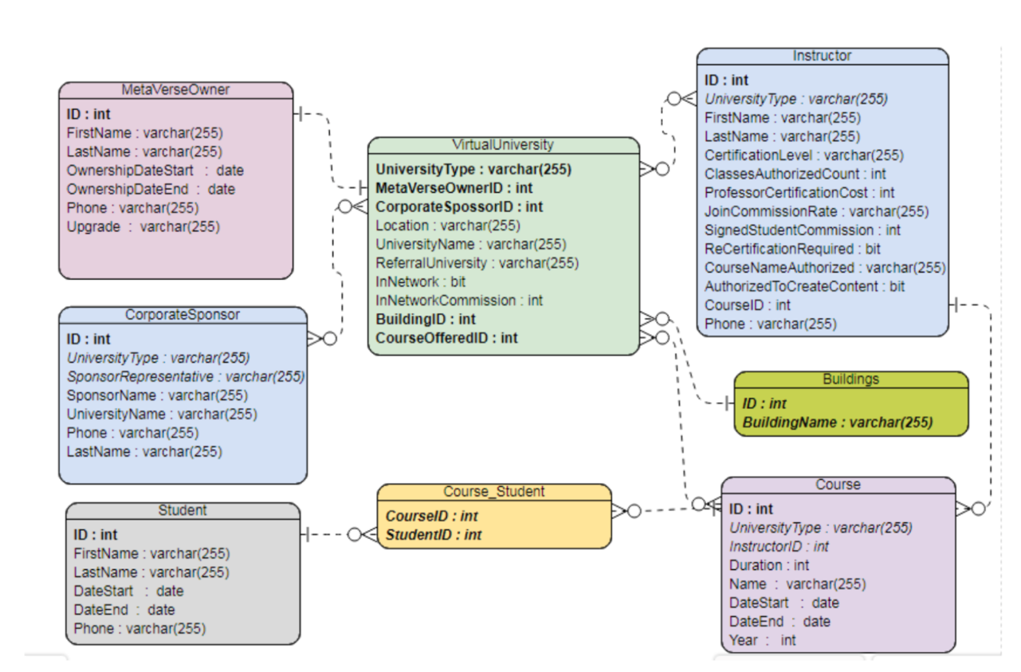

Appendix B – User Interface Mockup (for further details use the link)
https://www.figma.com/file/mon2H6oqfJorAL89nX6yDn/profile-page?node-id=107%3A56

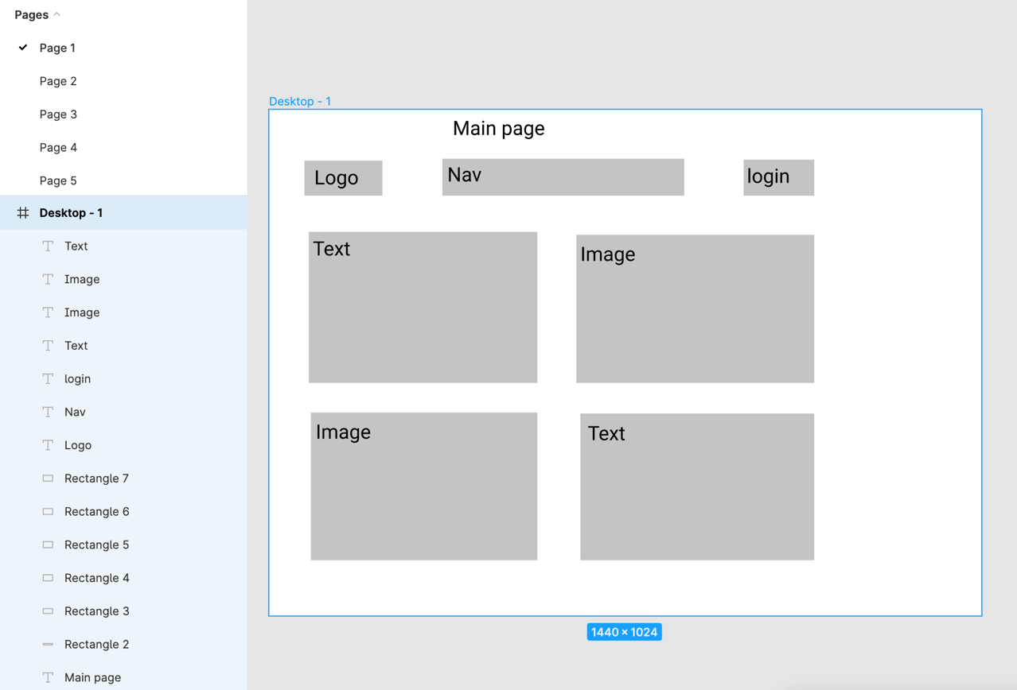

Appendix C – Process Flow Graph

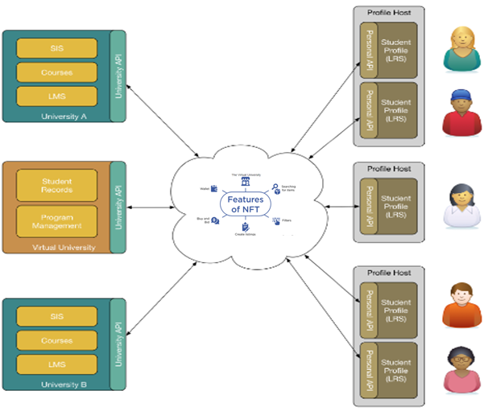
Appendix D – NFT Flow Mockup

